HANDY HOMES
“From Hands To Homes:-Connecting Local artists with the world.”

- Website/ app rough sketch
- Homepage
- Starts with tagline
- Image/banner showing pottery, handicrafts, artisans at work.
- “shop now” & “join as an Artisan” buttons.
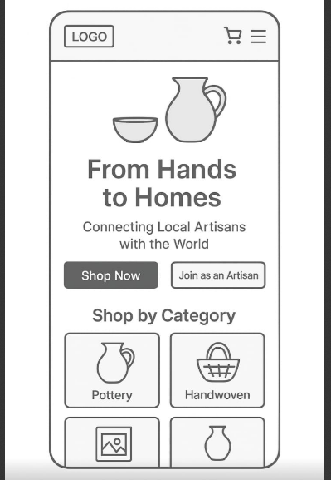
- Categories Page
- Pottery
- Handwoven craft
- Panting
- Home decor
- Accessories

- Product page
- Photos of the item (zoom to detailing’s)
- Description : Material, size, story of the artisan.
- Price and in drop down “Add to cart” button.
- “Meet the artisan” section with artisan bio.

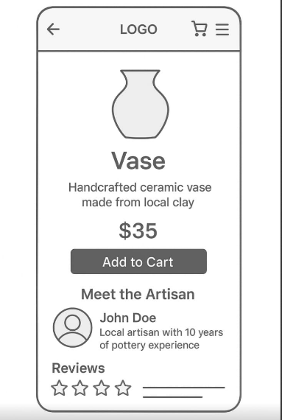
- Artisan Profiles
- Name, picture and background
- Gallery of works.
- Customer reviews.

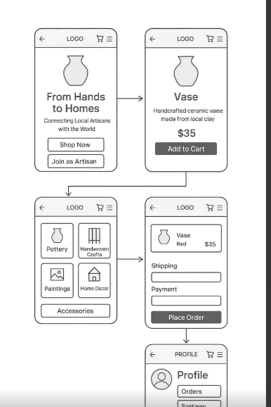
- Cart and checkout
- Multiple payment options
- Shipping details

- Contact & support
- Chat box and help center
- FAQs

